**Experiment no. 4**

**Name: Sonali Dattatray Kaingade**

**PRN: 21620002**

**Title:** Find info gain of an attribute from given data.

**Code:**

#include <iostream>

#include <fstream>

#include <sstream>

#include <map>

#include <cmath>

using namespace std;

// Function to calculate entropy

double calculateEntropy(int positive, int negative)

{

    double total = positive + negative;

    double entropy = 0.0;

    if (total > 0)

    {

        double positiveProbability = positive / total;

        double negativeProbability = negative / total;

        if (positiveProbability > 0)

        {

            entropy -= positiveProbability * log2(positiveProbability);

        }

        if (negativeProbability > 0)

        {

            entropy -= negativeProbability * log2(negativeProbability);

        }

    }

    return entropy;

}

// Function to compute information gain

double computeInformationGain(map<string, int> &parentCounts, map<string, map<string, int>> &childCounts)

{

    double positiveParent = parentCounts["Yes"];

    double negativeParent = parentCounts["No"];

    double totalParent = positiveParent + negativeParent;

    double parentEntropy = calculateEntropy(positiveParent, negativeParent);

    cout << "Parent Entropy: " << parentEntropy << "\n";

    double childEntropy = 0;

    for (auto it = childCounts.begin(); it != childCounts.end(); ++it)

    {

        string childName = it->first;

        double positiveChild = it->second["Yes"];

        double negativeChild = it->second["No"];

        double totalChild = positiveChild + negativeChild;

        double childEntropyPart = calculateEntropy(positiveChild, negativeChild);

        childEntropy += (totalChild / totalParent) * childEntropyPart;

    }

    cout << "Weighted Child Entropy: " << childEntropy << "\n";

    double informationGain = parentEntropy - childEntropy;

    cout << "Information Gain: " << informationGain << "\n";

    return informationGain;

}

int main()

{

    ifstream file("info-gain.csv");

    string line, day, level, routine, playGame, value;

    map<string, int> parentCounts;

    map<string, map<string, int>> childCounts;

    if (!file.is_open())

    {

        cerr << "Error opening input file." << endl;

        return -1;

    }

    int i = 0;

    string childName;

    int choice;

    while (getline(file, line))

    {

        stringstream str(line);

        getline(str, day, ',');

        getline(str, level, ',');

        getline(str, routine, ',');

        getline(str, playGame, ',');

        getline(str, value, ',');

        if (i == 0)

        {

            i++;

            cout << "Enter Child Column Number: ";

            cin >> choice;

            continue;

        }

        switch (choice)

        {

        case 1:

            childName = day;

            break;

        case 2:

            childName = level;

            break;

        case 3:

            childName = routine;

            break;

        case 4:

            childName = value;

            break;

        default:

            childName = routine;

            break;

        }

        parentCounts[playGame]++;

        childCounts[childName][playGame]++;

    }

    double informationGain = computeInformationGain(parentCounts, childCounts);

    cout << "Overall Information Gain: " << informationGain << "\n";

    return 0;

}

**Input file:**

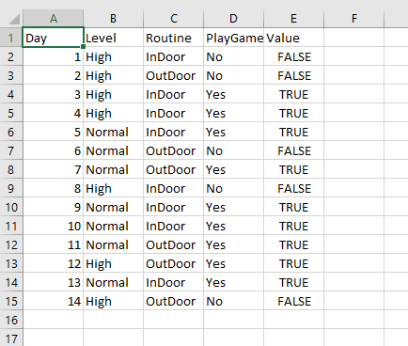

**Output:**

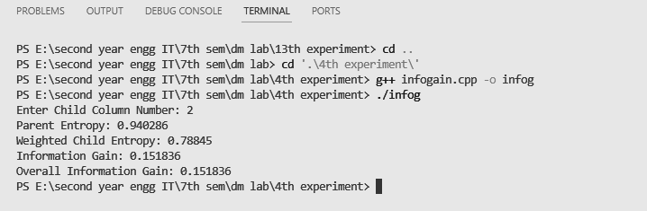

**knime:**

